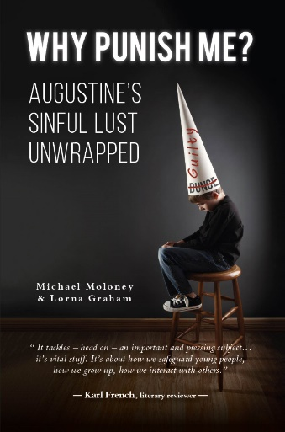
FOR RELEASE ON 21st SEPTEMBER 2021
Subject: BOOK LAUNCH
Item Length: 400 words – (300 words excluding final paragraph)
Title: Why Punish Me? Augustine’s sinful lust unwrapped
Scheduled for publication 28th September 2021
Author/Contact: Michael Moloney
Mob: 07766518633
Email: Michael@mike-molony.com
Web: https://mike-moloney.com/media (review copies, etc.)

THE SHAMEFUL STORY OF SIN INSIDE OUR CHURCHES
The ‘God Debate’ is given a shot in the arm with this new assault on St Augustine. Available from 28th September, Why Punish Me? is a meticulously annotated account, initially from a child’s-eye viewpoint, of Augustine’s fourth century teaching. The author served as altar boy and chorister while attending church boarding schools in Ireland and England, where he faced abuse. Tracing his religious background, he recalls his daily prayers of self-censure and remorse, a penitential ritual still practised in many British schools.
He writes “Having a sensitive nature is a positive attribute; it is what makes us human. But imaginative and impressionable individuals are susceptible to corrosive feelings of guilt and shame. These feelings are sharpened by the ritual avowals of self-blame decreed by Augustine, the bedrock of Christian belief in the West.”
The Church of England service admits sin and begs forgiveness or mercy twenty-four times. Grace and love are said twice. Some children in faith schools today recite a shorter, but similarly mortifying version, often led by a cleric. Schools do not set out to sexualise pupils, but the NSPCC children’s charity lists ‘an authority figure causing a child to feel guilt and shame’ as a known method of child sexual grooming.
The author points out that clerical child sexual abuse is far from a historical problem. The UK independent inquiry reported in 2020 that more than 100 new cases are being recorded every year. Yet nothing in literature explains this deviance credibly. Here the possible influence of drill and doctrine on the sexual abuse of children and the callous neglect found in Ireland’s mother and baby homes, is explored in depth. We see how Augustinian theology, endorsed by teachers in many of Britain’s faith schools, might play a role in clerical child sexual abuse and adult mental well-being.
Why Punish Me? reviews research papers endorsing religiosity and suggests a lack of rigour. Academics tend to shun religion as a field of study and in these pages we discover why. This book is a valuable read for all parents and teachers, indeed anyone involved in education or child care. The distinguished literary reviewer KARL FRENCH commented “It tackles – head-on – an important and pressing subject. …it’s vital stuff. It’s about how we safeguard young people, how we grow up, how we interact with others, how we see ourselves.”

###

